Stop guessing; start knowing. Digitalise your compressed air.
By Karol Malicki, Head of Technical Sales Support, SMC Poland
If you’re not measuring your compressed air, you’re making decisions in the dark. The good news? Gaining real visibility is far easier and more valuable than you might think.

Let’s keep this simple: you can’t manage what you don’t measure. Sure, you’re under pressure to improve efficiency, reduce costs, hit sustainability targets or just keep production running smoothly. But when we ask: “Do you know exactly how your compressed air is performing at machine level?” The answer we often hear on our site visits is…not really.
And that’s completely understandable. Compressed air is one of those utilities that quietly does its job in the background. Until it doesn’t. The problem is, without real data, you’re relying on assumptions. You might think your system is efficient. You might suspect there are leaks or pressure drops. But without measurement, you don’t actually know.
Digitalisation changes that. It replaces guesswork with facts, and that’s where the real improvements begin.
Why it matters
Here’s something worth contemplating: compressed air generation typically accounts for a staggering 20% of a factory’s total energy usage. And when we break that down further, it gets even more interesting. Air blowing alone can represent over 40% of compressed air consumption, while actuators account for around 14% and vacuum applications approximately 9%.
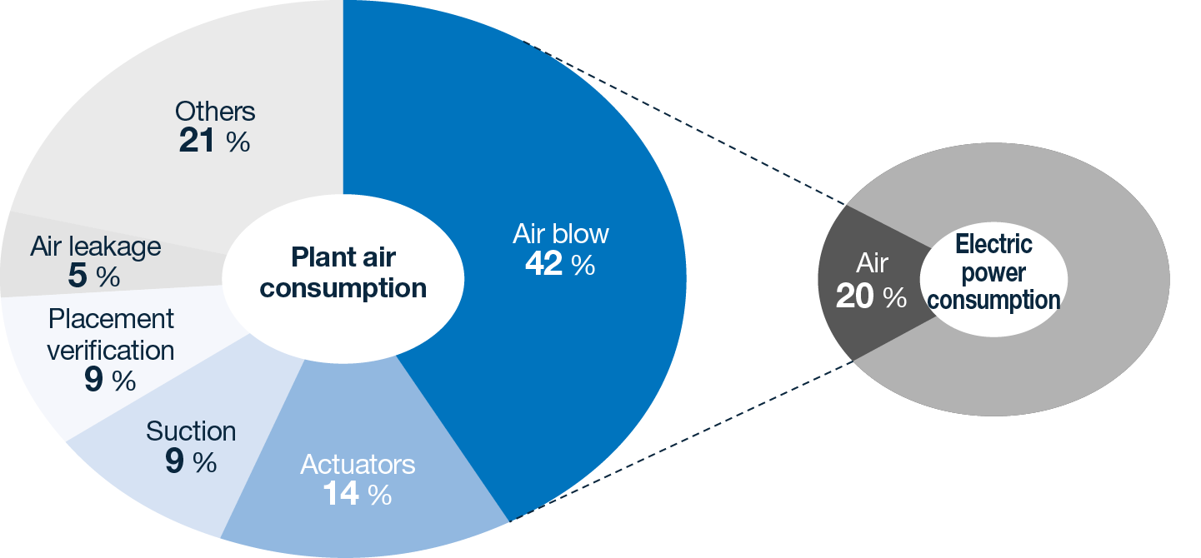
Chart extracted from SMC´s catalogue “Proposal for energy saving in factories”

So, if you’re looking at energy efficiency or CO₂ reduction, compressed air is not a small lever. It’s a big one. But here’s the catch: many factories still only measure air consumption at the compressor. That gives you a high-level picture, but it doesn’t tell you what’s actually happening on the shop floor.
Where is air being wasted? Which machines are consuming more than they should? Are you paying for inefficiencies without realising it? To answer those questions, you need to go deeper.
A deep dive
This is where digitalisation really starts to make a difference. Instead of a single measurement point, we help you monitor compressed air at machine level, where the real insights can be found. By installing flow sensors, pressure sensors and humidity monitoring devices at critical points, you start to build a clear, data-driven picture of your operations.

And once that data is available digitally, everything changes. You can see real consumption per machine or process, understand pressure stability across your network, and spot early signs of component wear or system imbalance. Suddenly, you’re not reacting to problems, you’re anticipating them.
It’s not just energy
Now, some of you are already focused on energy efficiency. Maybe you have CO₂ reduction targets, internal sustainability goals or rising utility bills to tackle. In those cases, digitalisation is an obvious win. We can visit your site, conduct a pre-audit, measure key points and calculate ROI based on real data, not estimates. From there, it’s about targeted improvements, whether that means optimising devices, improving air blow efficiency or refining distribution.
But here’s the interesting part: not everyone starts with energy as their priority. Sometimes the real challenge is production. If you’re dealing with inconsistent cycle times, quality issues or unexplained downtime, compressed air could be part of the story.
With digitalisation, you’re able to link air consumption and pressure behaviour directly to machine performance. That means you can identify the root cause of process instability, avoid quality defects linked to pressure variation and even calculate the true cost of air per product. No more approximations or estimates. Just real numbers to support real decisions.
Stay ahead of issues
One of the biggest advantages of digitalising your compressed air system is how quickly it prompts investigations and actions. A gradual pressure drop, for instance, could point to distribution issues or compressor limitations. Changes in flow patterns might indicate leaks or incorrect settings, while rising humidity levels could signal dryer performance problems.
These are the kinds of issues that, left unchecked, lead to downtime, scrap or higher maintenance costs. With the right data and the right alerts, you can intervene early, before they impact production. That’s what predictive maintenance should look like in practice.
Start small, think smart
One concern we hear a lot is: “Digitalisation feels like a big leap.” It doesn’t have to be. In fact, the most effective approach is often step-by-step. You might start with a single machine or production line, adding measurement points where they matter most, before building from there as confidence and understanding grow.
Modern systems make this strategy easier than ever. Technologies like IO-Link, wireless communication and open protocols such as OPC UA mean integrating sensors into your existing set up is straightforward and cost-effective.
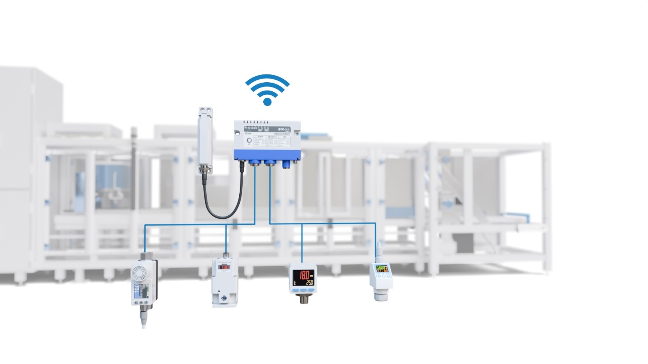
Wireless fieldbus system centralises information and enables communication over distances of up to 100 meters

From data to action
Of course, collecting data is one thing. Turning it into meaningful gains is another. That’s why experience really matters. At SMC, we don’t just provide automation components, we work to understand your factory, identify critical measurement points and translate data into practical actions. That might begin with installing flow meters or our Air Management System to establish a clear baseline. From there, we look beyond obvious issues like leaks and focus on optimising the full system, uncovering inefficiencies that often go unnoticed.
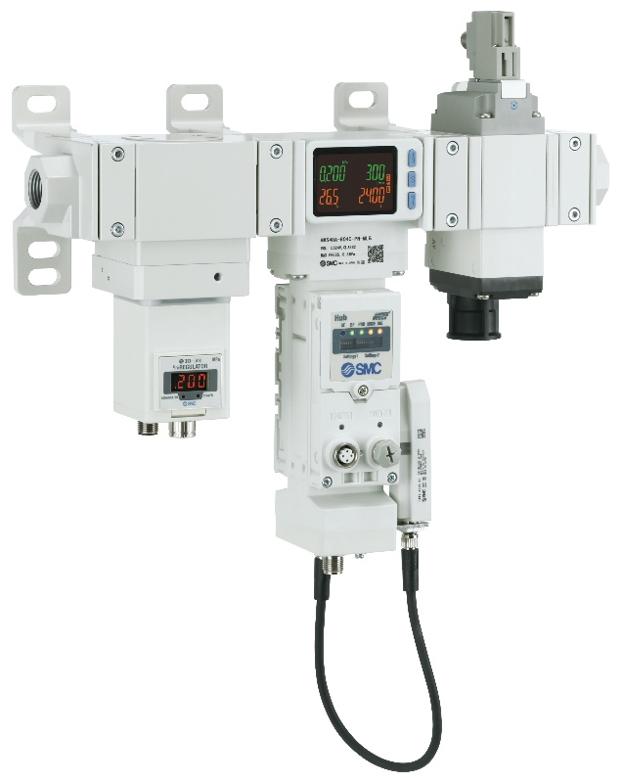
We ultimately propose targeted equipment or system improvements, while supporting your team with training and ongoing optimisation to ensure long-term benefits. In short, we help you move from ‘interesting data’ to ‘measurable results’.
SMC´s Air Management System – AMS 20/30/40/60 Series

